**NAME : Gajera Pal**

**Create the product table**

CREATE TABLE product (

PRO_ID INT PRIMARY KEY,

PRO_NAME VARCHAR(100),

PRO_PRICE DECIMAL(10,2),

PRO_COM INT

);

**Output**

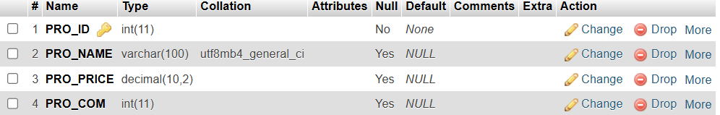

**Insert Sample Data**

INSERT INTO product (PRO_ID, PRO_NAME, PRO_PRICE, PRO_COM) VALUES

(101, ‘Mother Board’, 3200.00, 15),

(102, ‘Key Board’, 450.00, 16),

(103, ‘ZIP drive’, 250.00, 14),

(104, ‘Speaker’, 550.00, 16),

(105, ‘Monitor’, 5000.00, 11),

(106, ‘DVD drive’, 900.00, 12),

(107, ‘CD drive’, 800.00, 12),

(108, ‘Printer’, 2600.00, 13),

(109, ‘Refill cartridge’, 350.00, 13),

(110, ‘Mouse’, 250.00, 12);

**Output**

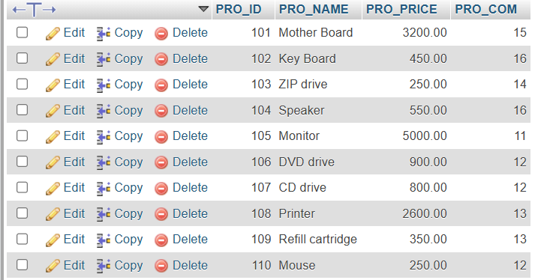

**Write sql query to find the items whose prices are higher than or equal 250rs.**

SELECT PRO_NAME, PRO_PRICE

FROM product

WHERE PRO_PRICE >= 250 ORDER

BY PRO_PRICE DESC, PRO_NAME ASC;

**Output**

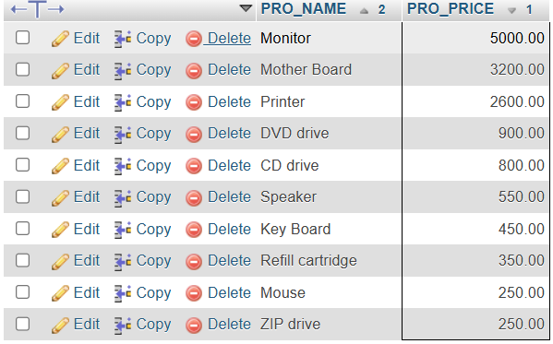

**Write a sql query to find the cheapest item.**

SELECT PRO_NAME, PRO_PRICE

FROM product

ORDER BY PRO_PRICE ASC

LIMIT 1;

**Output**

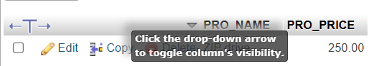

**Write the sql query to calculate the average price of the items for each company**

SELECT PRO_COM, AVG(PRO_PRICE) AS AVG_PRICE

FROM product

GROUP BY PRO_COM;

**Output**

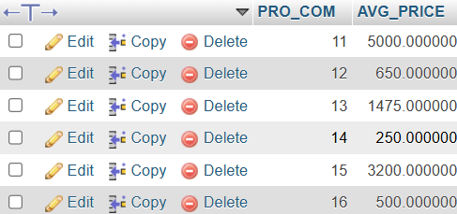

**Write the sql query to find the average total for all the product mention in the table**

SELECT AVG(PRO_PRICE) AS TOTAL_AVG_PRICE

FROM product;

**Output**

